Proceedings of the 9th Asian Conference on Refrigeration and Air-conditioning
ACRA2018
June 10-13, 2018, Sapporo, JAPAN

ACRA2018-XXXXX

AUTHOR INSTRUCTIONS FOR FULL PAPER PREPARATION

Author Name¹⁾, Taro J. Reito²⁾, and Ku-Cho Shokuhin²⁾*
¹⁾Department or Division Name, Company or University Name, Street or P.O. Box, City, State, ZIP Code, Country
²⁾Department or Division Name, Company or University Name, Street or P.O. Box, City, State, ZIP Code, Country

ABSTRACT: This document provides information and instructions for preparing a manuscript of ACRA2018 on author-prepared A4 size paper (210 × 297 mm). Follow the specifications in this document to determine the layout of your pages. If you follow the instructions included here, the typeface style (Times Roman font), the font size (10 points) and basic layout of your paper should look like this document. Font size of the text should be 10 points, and text must be typed single-spaced (10 points), one columns a page. Begin your page 20 mm from the top of the page. Both right and left margins are 20 mm, and bottom margin is 25 mm for A4 size paper. The ABSTRACT heading should be 10 pt. boldface in all capitals; it should be in a Times Roman typeface. It should be flush left with the left margin. The preferred spacing to the next heading is one (1) line space. The abstract must not exceed 200 words.

Keywords: Keyword1, Keyword2, Keyword3, Keyword4, Keyword5

1. PAPER LENGTH

Author-prepared full manuscript length must be 4 pages including figures and tables.

2. PAPER TITLE AND AUTHOR(S)

The title of your paper and the author(s) should be included in the space. Paper title and author name(s) are typed centered.
The title should be 14 pt. boldface in all capital letters; it should be in a Times typeface with 14 pt. line spacing. The title should be centered on the page, and all lines (including run-over lines of a long title) should be centered. One line space separates the title from the first author.
Author name should consist of first name, middle name, and last name. It should be 10 pt. boldface Times, upper and lower case letters (with 10 pt. of line spacing), centered under the title. Put an asterisk (*) at the rear of the speaker’s name. Author affiliation should consist of the following as applicable and in the order noted:

• department or division name
• company or university name
• street or P.O. box
• city, state, and ZIP Code
• country name

Professional titles should not be included. All author affiliation information should be 10 pt. Italic, upper and lower case letters with 10 pt. line spacing, centered under the name.

3. ORGANIZATION OF PAPER

Papers are organized in the following order: abstract, main body, acknowledgments, nomenclature, references, and appendices.

4. NOMENCLATURE

The nomenclature list is in alphabetical order, followed by any Greek symbols. Subscripts and superscripts are listed last and are identified with headings. The nomenclature should be listed in two columns.

5. USE OF SI UNITS

SI (Metric) units of measurement are to be used. When U.S. customary units are given preference, SI units should be also given in parentheses.

6. TEXT

Type single space (10 pt.) like this guide. The text should be 170 mm wide and justified on the right and left margins. The first line of each paragraph should be indented five spaces from the left margin.

7. MAJOR HEADING

The major heading should be 10 pt. Times boldface in all capitals, flush left with the left margin. If the major heading should run to more than one line, the run-over text should also be flush left. One line of space is left above and below the major heading.

7.1 Sub Headings

The next level of heading should be 10 pt. Times boldface, typed with the initial letter of each word capitalized. The heading is flush left with the left margin. One line of space is left above and below the subheading, and the text begins on the line below it.

Sub-subheadings The third level of heading should be indented five spaces, underlined, and followed by two spaces and text. A space is left above the sub-subheading.

8. EQUATIONS

Each equation starts with around ten space indent and allow one line of space above and below. When two or more equations are listed in series, the line space between equations are not necessary.
Equation numbers should be Arabic numerals enclosed in parentheses which should be flush right. They should be cited in the text as, for example, Eq. (11), or Eqs. (21)-(23).

E = mc² (1)

9. FIGURES/PHOTOGRAPHS

All figures, graphs and line drawings should be clear and sharp and of high quality (photocopies are not acceptable). Figures may be placed either at the end of the paper or within the text of the paper, immediately following the text reference of the figure. If figures are placed within the text of the paper, it is preferable to position them at the top or bottom of the paper. They should be referred to in the text as, for example, Fig. 10, or Figs. 11-14.
All figures should be in place when your paper is submitted for publication.
Photographs, like figures, should be placed directly on the page, either at the end of your paper or within the text of the paper. Photographs should be sized to accurately fit the page specifications.
All figures/photographs should be numbered consecutively and captioned. Place figure caption below the figure. The caption is a title or description of the figures/photographs and includes the figures/photographs number. The caption should followed the style, for example, ‘Fig. 1 Schematic diagram’. All numbers and text within the figure should be no smaller than 8 pt.
There should be a minimum of one line space between figures/photographs and text.

10. TABLES

All tables should be numbered consecutively with Arabic numerals and captioned. The caption should followed the style, for example, ‘Table 1 Test conditions’. The body of the table should be no smaller than 8 pt. The use of boldface and italics is encouraged to make necessary distinctions within the table.

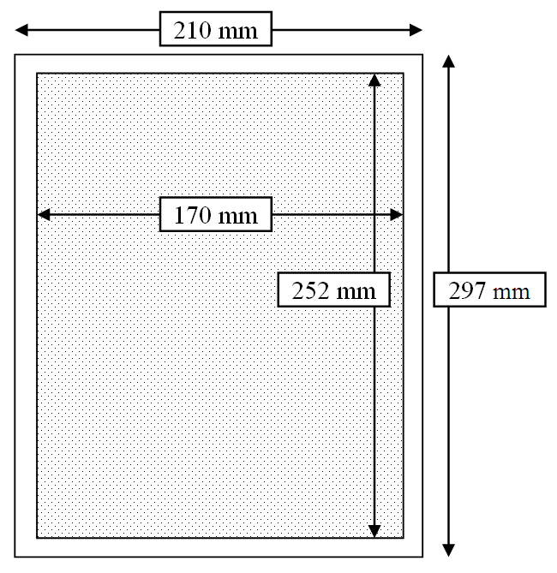
Fig. 1 Thermal conductivity Fig. 2 Text area of manuscript

Table 1. Page margins of manuscripts. Enter one blank line below each Table.

Margin Position | Top | Bottom | Left | Right
Margin size (mm) | 20 | 25 | 20 | 20

Tables should be positioned at the top or bottom of the page. As with all figures, all tables should be in place on the page when the final paper is submitted. There should be a minimum of one line spaces between tables and text.

NOMENCLATURE
c_{p} | : specific heat at constant pressure, kJ/(kg･K) | V | : volume, m³
h | : specific enthalpy, kJ/kg | Subscript
p | : pressure, kPa | a | : air
T | : temperature, K | Superscript
t | : Celsius temperature, ºC | sat | : saturation

REFERENCES

When referring to them in the text, type the reference number in brackets, e.g., [1]. Literature references should be grouped at the end of the paper in the order of citation. In the reference list, write all authors’ names.
Style the reference list according to the following examples. Abbreviate journal titles according to standard forms (Note especially that article and chapter titles are included).

(Book)
[1] Reid, R. C. and Sherwood, T. K., 1966, The Properties of Gases and Liquids, pp. 1-25, McGraw-Hill, New York.

(Chapter in edited book)
[2] Davis, P. J., 1962, Orthonormalization codes in numerical analysis, in Survey of Numerical Analysis, ed. John Todd, 2nd ed., Vol. 1, pp. 33-39, McGraw-Hill, New York.

(Journal article)
[3] Denny, V. E. and Mills, A. F., 1969, Non similar solutions for laminar film condensation on a vertical Surface, Int. J. Heat Mass Transfer, Vol. 12, pp. 965-979.

(Report)
[4] Bell, K. J. and Taborek, J., 1969, Survey of Condensation Heat Transfer and Condenser Design, HTRI Report. C-G-1-1, April.

(Unpublished paper)
[5] Suitor, J. W., Marner, W. M., and Ritter, R. B., 1976, The history of heat exchangers in cooling water service, 16th Natl. Heat Transfer Conf., St. Louis, CSME/CSChE Paper 76.

(Symposium proceedings)
[6] Wilkie, D., 1966, Forced convection heat transfer from surfaces roughened by transverse ribs, Proc. 3rd Int. Heat Transfer Conf., Chicago, Vol. 1, pp. 21-28.

(Thesis)
[7] Graham, C., 1969, The Limiting Heat Transfer Mechanism of Dropwise Condensation, Ph.D. thesis, Massachusetts Institute of Technology, Cambridge, Mass.

13. DEADLINE AND WHERE TO SUBMIT A FULL PAPER

Full manuscript submission due is February 16, 2018. All papers should be submitted to the conference website (http://www.acra2018.org) as PDF files. The size of a PDF file must be within 4 MB.
Please leave the manuscript number “ACRA2018-XXXXX” as it is. The number will be assigned later by the organizing committee.

